Assignment-09
2303A51960
Task 1: Auto-Generating Function Documentation in a Shared Codebase
Prompt:
# I have joined a development team where several utility functions are already implemented, but the code lacks proper documentation. New team members are struggling to understand how these functions should be used.
# I have given a Python script containing multiple functions without docstrings. Generate the Google-style function doc strings for each function.Each docstring should include (A brief description of the function, Parameters with data types, return values, At least one example usage(if applicable)).
# Example function without docstring
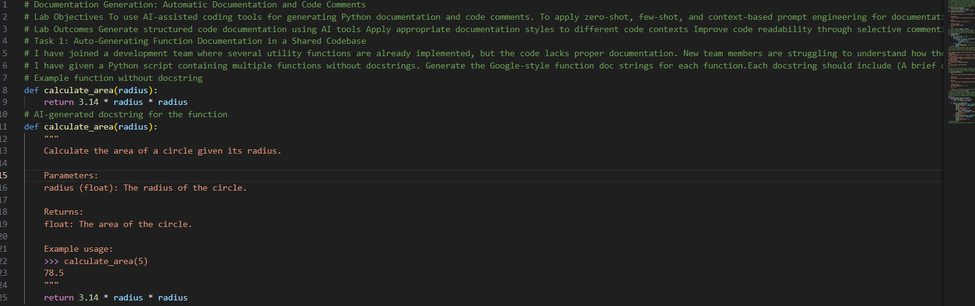
Task 2: Enhancing Readability Through AI-Generated Inline Comments
Prompt:
# A Python program contains complex logic that works correctly but is difficult to understand at first glance. Future maintainers may find it hard to debug or extend this code.
# I have given a Python script containing ( loops, conditional logic and algorithms). Use AI assistance to Automatically insert inline comments only for complex or non-obvious logic Avoid commenting on trivial or self-explanatory syntax The goal is to improve clarity without cluttering the code.
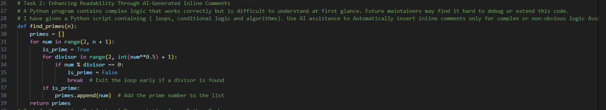
Task 3: Generating Module-Level Documentation for a Python Package
Prompt :
# our team is preparing a Python module to be shared internally (or uploaded to a repository). Anyone opening the file should immediately understand its purpose and structure.
# Task Description Provide a complete Python module to an AI tool and instruct it to automatically generate a module-level docstring at the top of the file that includes: (The purpose of the module, Required libraries or dependencies, A brief description of key functions and classes, A short example of how the module can be used )Focus on clarity and professional tone.
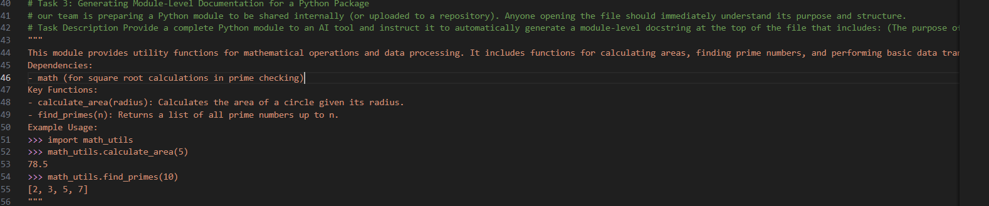
Task 4: Converting Developer Comments into Structured Docstrings
Prompt :
# Scenario: In a legacy project, developers have written long explanatory comments inside functions instead of proper docstrings. The team now wants to standardize documentation.
# Task Description: You are given a Python script where functions contain detailed inline comments explaining their logic.Use AI to: Automatically convert these comments into structured Google-style or NumPy-style docstrings. Preserve the original meaning and intent of the comments. Remove redundant inline comments after conversion
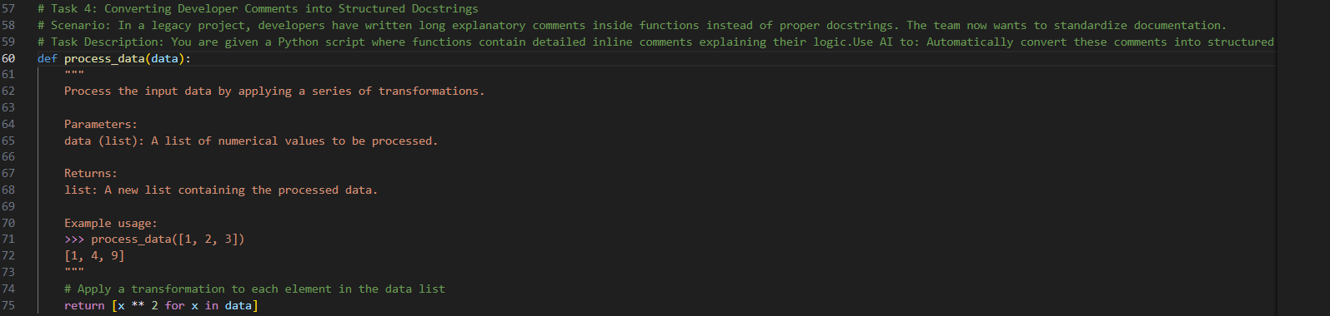
Task 5: Building a Mini Automatic Documentation Generator
Prompt :
# Scenario: our team wants a simple internal tool that helps developers start documenting new Python files quickly, without writing documentation from scratch.
# Task Description: Design a small Python utility that: Reads a given .py file, Automatically detects:, Functions, Classes, Inserts placeholder Google-style docstrings for each detected function or class AI tools may be used to assist in generating or refining this utility.
# Note: The goal is documentation scaffolding, not perfect documentation.
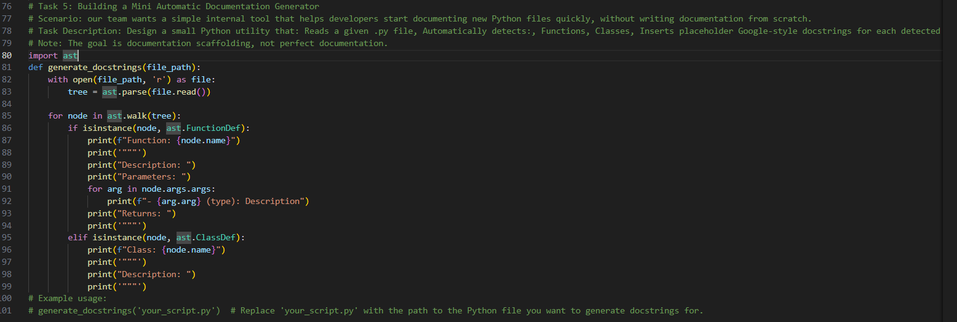
Code Explanation :

# Task-1: The original function definition was missing a colon at the end of the function signature, which is a syntax error in Python. The corrected version includes the colon, allowing the function to be defined properly.
# Task-2: The original function lacked inline comments, making it difficult to understand the logic at first glance. The AI-generated comments explain the purpose of each step in the function, improving readability without cluttering the code.
# Task-3: The module-level docstring provides a clear overview of the module's purpose, its dependencies, key functions, and an example of how to use it. This helps new users quickly understand what the module does and how to utilize it effectively.
# Task-4: The original function contained detailed inline comments that explained the logic. The AI-generated docstring captures the essence of these comments in a structured format, making it easier for users to understand the function's purpose, parameters, and return values at a glance.
# Task-5: The utility function uses the Abstract Syntax Tree (AST) module to parse a Python file and detect function and class definitions. It then prints out placeholder docstrings for each detected function and class, providing a scaffold for developers to fill in with actual documentation. This helps standardize documentation across the codebase and encourages developers to document their code properly.

